
www.FASTBusinessPlans.com

Business Plan
(Café Business plan)

the russet cup
13351 Mission street
(overland park, KS)

(date)

Use and Reprint Rights for Your FAST Business Plan Template

This template has been written to include instructions for creating your final business plan. You are free to edit and use the material within your organization. However, please do not distribute this template online or elsewhere publically without explicit permission from us.

Table of Contents

1.0 Executive Summary 4
1.1 Business Objectives 4
1.2 Mission Statement 4
1.3 Guiding Principles 4
1.4 Keys to Success 5
2.0 Company Description 5
2.1 Ownership 5
2.2 Legal Form 5
2.3 Start-Up Summary 5
2.4 Location and Facilities 6
3.0 Products/Services 7
3.1 Products/Services Descriptions 7
3.2 Competitive Comparison 7
3.3 Product/Service Sourcing 9
3.4 Inventory Management 9
3.5 Warehousing and Fulfillment 9
3.6 Future Products/Services 9
4.0 Market Analysis 9
4.1 Industry Analysis 10
4.1.1 Market Size 11
4.1.2 Industry Participants 11
4.1.3 Main Competitors 12
4.1.4 Market Segments 14
4.2 Market Tests 15
4.3 Target Market Segment Strategy 16
4.3.1 Market Needs 16
4.3.2 Market Trends 16
4.3.3 Market Growth 17
4.4 Positioning 17
5.0 Marketing Strategy and Implementation 17
5.1 SWOT Analysis 18
5.1.1 Strengths 18
5.1.2 Weaknesses 18
5.1.3 Opportunities 18
5.1.4 Threats 18
5.2 Strategy Pyramid 18
5.3 Unique Selling Proposition (USP) 19
5.4 Competitive Edge 19
5.5 Marketing Strategy and Positioning 19
5.5.1 Positioning Statement 19
5.5.2 Pricing Strategy 20
5.5.3 Promotion and Advertising Strategy 20
5.5.4 Website 20
5.5.5 Marketing Programs 20
5.6 Sales Strategy 20
5.6.1 Sales Forecast 21
5.6.2 Sales Programs 21
5.7 Legal 21
5.8 Milestones 21
5.9 Table 5.8 Milestones 22
5.10 Exit Strategy 22
6.0 Organization and Management 22
6.1 Organizational Structure 22
6.2 Management Team 22
6.3 Management Team Gaps 22
6.4 Personnel Plan 22
6.5 Board of Directors 23
7.0 Financial Plan 23
7.1 Important Assumptions 23
7.2 Start-Up Costs 24
7.3 Source and Use of Funds 25
7.4 Break-Even Analysis 26
7.5 Projections 26
7.5.1 Projected Profit and Loss 26
7.5.2 Projected Cash Flow 28
7.5.3 Projected Balance Sheet 29
7.6 Business Ratios 29

1.0 Executive Summary
The Russet Cup will be a one of a kind coffee house / café located in Overland Park, Kansas. The 1,500 square foot café will be located in the newly constructed Market Square Plaza located on the northeast corner of 135th Street and Mission Street. The anchor tenant, the Price Chopper grocery store, has already taken occupancy and the excellent location brings more than 10,000 shoppers weekly.

The Russet Cup, aptly named for the aromatic brown liquid that will fill the cup, fills the void of original cafes in the market area, stands out from its corporate peers with their fast food concepts and fast services. The Russet Cup is the alternative to fast food/commercial/coffee shops and offers a much calmer, civilized gourmet coffee experience. There are no televisions in the café, the background music is subtle and work from local artists will hang on the walls.
The café is well appointed with overstuffed leather chairs and sofas in a library like setting. The café is reminiscent of times gone by – yet is cutting edge technologically with WIFI and state of the art espresso machines.

The Russet Cup measures its financial success in terms of increased market share and in earnings. With a total local market of $54 million, this is a tremendous opportunity! The keys to success will be the ability to offer quality gourmet coffees, take advantage of its small size, and reliance on an outstanding barista staff. In order to achieve these goals, the café will offer some the area’s finest gourmet beans from local distributors. Because of its small size, the café can enjoy larger margins in the form of lower overhead. The cafe will hand select baristas and offer salaries comparable to the chains. In turn the baristas will be trained to cross-sell, and sell the higher margin products.

Business Objectives
The primary objectives of the business plan for Russet Cup are below:
- To increase revenues $36,000 or 5% in Year 2 and by $73,000 or 10% by Year 3
- Achieve a profit margin of 5.2% in Year 2 and 6.90% by Year 3
- Be the Café of Choice in the Overland Park area and recipient of the Best Coffeehouse Award

Mission Statement
The Russet Cup is committed to its products and employees which they believe is the recipe for market success.

Guiding Principles
The Russet Cup is committed to values such as excellence, passion, quality, integrity and leadership which allow them to navigate challenges and provide for future opportunities. These core beliefs start with their commitment to their products and their employees.
The Russet Cup rewards excellence and cherishes loyalty. The café will work with its employees to build strong businesses and a secure future.

Keys to Success
The Russet Cup stands out from the competition. Below are their Keys to Success:

- Great Products – providing exemplary products at market prices – will make customers want to return again and again
- Hire Quality Baristas – Pay employees rates similar to the larger chains with opportunities for long term careers and opportunities for advancement with long term plans to open a second facility
- Convert Customers to Connoisseurs - Only 40% of the nations coffee drinkers consume premium ground and whole bean coffee – this will aid in continued growth

Company Description
The Russet Cup will be a coffee house / café located in the Overland Park, Kansas. Located in the Kansas City area, the cozy café will be located in the newly completed Market Square Plaza. The café will serve gourmet coffees, espresso and drip coffee, lattes, and smoothies. The simple pastry offerings may vary with seasonality but the primary line will be muffins, breads, cookies, scones, and rolls. All pastries will be supplied daily by a local bakery.
The café will be owned and operated by Owen Jones, a veteran restaunteur with several years experience running and managing chain restaurants. The café will be open for business Monday – Thursday 7-10, Fridays and Saturdays 7-11 and closed Sundays.

Ownership
The Russet Cup will be owned 100% by Owen Jones. Mr. Jones a graduate of Kansas State University has an undergraduate degree in business administration. During high school he worked as a waiter in a local hospital coffee shop that purchased its beans from a local roaster. In addition to being an avid coffee drinker himself, this job allowed him to learn about the business first-hand. In college, Jones worked in a campus coffeehouse for four years, eventually rising to the position of assistant manager. Following graduation, Jones secured a business development position for regional restaurant chain, which provided additional first-hand exposure to the food and beverage industry—especially the steps involved in establishing new locations.

Legal Form
The Russet Cup will be formed as an S-Corporation wholly owned by Mr. Jones.

Start-Up Summary
The Russet Cup will have seating for 40 patrons. The rent is $2,075 a month, with a three-five-year lease available. The site consists of 1500 square feet of leased space consisting of a dining room, a coffee bar, two restrooms, and a storage room in back. To be used as a restaurant, this storefront needs to be plumbed and wired appropriately. Painting, new floors, and countertops are also needed. A custom coffee bar needs to be built. With materials bought on sale and volunteer labor, the cost to renovate will be $71,725. The coffeehouse equipment will consist of two commercial espresso machines, air pots and urns, a commercial blender, commercial brewer, top loading coffee bins, barista syrups, cold drink dispenser, frothing equipment, a commercial refrigerator, microwave and stainless steel prep bar. The cost for the equipment is $38,275. The furniture will consist of leather couches, and chairs (purchased at auction), coffee tables, bookcases, and window treatment. The artwork will come from local artists and will be sold on a consignment basis. The books were secured via donations. Total cost to furnish is $14,000. Other startup expenses will be dishes, furniture, rent deposit, and marketing.

Location and Facilities
The new coffeehouse is located in the highly desirable Overland Park, Kansas area at the northeastern intersection of 135th Street and Mission Street in the new Market Square Plaza. The property is located in an excellent location. With an easy 6 minute drive time to I-435 and 69 Highway. The property is 95% leased with Price Chopper as the Anchor Tenant. Other tenants include: Life Spring Med Spa, Jane’s Canines (Pet Store & Boarding), Pride Cleaners Kahn Dental and Swim U. Price Chopper brings more than 10,000 shoppers per week to the center. The location is comprised of a population of 9,420 within a one mile radius, 61,102 within 2 mile radius and 149,550 within a 5 mile radius – with a median household income of $120,856. Sprint / Nextel’s corporate office is located within 2 miles of the site.

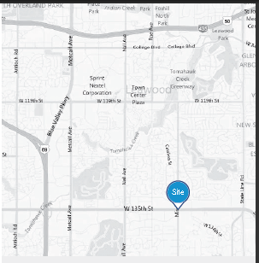

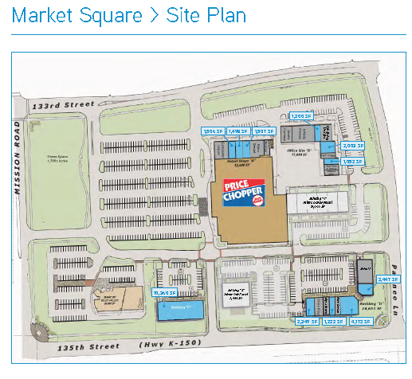

Products/Services

Products/Services Descriptions
The Russet Cup’s primary offering is gourmet roasted coffees with such varieties such as mocha, carmelicious, white mocha, candy bar latte, and brewed coffee. Complementing the coffee will be a smoothie line including wild berry, strawberry, peach, mango and lemonade. Rounding out the simple menu line will be pastries obtained with an outside supplier, freshly made and delivered daily. The pastry offerings may vary with seasonality but the primary line will muffins, breads, cookies, scones, and rolls.

Competitive Comparison
The research methodology is based on unique coffee shops/cafes in the greater metro area and omits larger chains or franchises. The findings reveal eight unique competitors.

Roasterie Café
4511 W 119th St
Leawood, KS 66209
http://www.theroasterie.com/Cafe/

Take Five Coffee Bar
5336 W 151st St
Overland Park, KS 66224-8701
http://www.takefivecoffeebar.com/Welcome_to_Take_Five_Coffee_Bar

Homer’s Coffee House
7126 W 80th St
Overland Park, KS 66204-3715
http://www.homerscoffeehouse.com/about.php

Morning Glory Espresso
5606 Johnson Dr
Mission, KS 66202-3323
http://www.morninggloryespresso.com/

Revo Cup Coffee
11030 Quivira Rd
Overland Park, KS 66210-1239
http://revocup.com/blog/

Daily Dose Coffee and Bar
12056 W 135th St,
Overland Park, Kansas

Java Crossing
8830 W 95th St
Overland Park, KS 66212-4051

Hattie’s Fine Coffees
4195 Somerset Dr
Prairie Village, KS 66208-5242
http://www.hattiesfinecoffee.com/Home_Page.html

Product/Service Sourcing
The Russet Cup has negotiated supplier agreements with several local food-service wholesalers and coffee wholesalers in the Overland Park area that have a reputation for quality and reliability:
- Mean Beans Coffee Roasters
- Overland Park Brewers
- Healthy Harvest Bread Co.
- Mary's Organics
In the event that one of the aforementioned specialty suppliers cannot meet their needs, the following national suppliers can both provide all of the food-service products that they require. In addition, the following wholesalers will supply the café with general restaurant supplies:
- Lawrence Food Products Corp.
- Gerry Food Supply Inc.

Inventory Management
N/A

Warehousing and Fulfillment
N/A

Future Products/Services
Young families which comprise the third largest market share in Overland Park, are often overlooked in the coffee market. Coffeehouses traditionally have not been considered ‘kid’ friendly. To overcome this hurdle, the Russet Cup has long term plans (5 years) to open a 2nd coffee shop: A combination indoor play area / coffee bar. This concept allows parents and caregivers an opportunity to meet and relax with other adults while the children can enjoy the indoor playground amenities.

Additional future services will include in-store sales for home purchase as well as an online store.

The website will have an option to purchase prepaid gift card program – Prepaid gift cards not only provide immediate cash, but also reduce credit card transaction charges and draw new customers to the business.

Market Analysis
Overland Park, Kansas is an award-winning place to live and work and is considered the leading business community in the Midwest. National publications and organizations recognize Overland Park for its business environment and livability. Here’s a sampling: 6th Place, America’s Best Places to Live Money, Top 50 Cities to Live and Play, National Geographic Adventure, 3rd Hottest Town in the U.S., Money, Among 20 Best Places to Live & Work Employment Review, One of only 72 Sterling Tree Cities in U.S., National Arbor Day Foundation, Top 10 best Locations to Raise a Family, Southern Business and Development, 1st Place, Kid Friendly Report Card, Population Connection, 2nd Best City in America to Live Business Development Outlook.

Overland Park is at the core of one of the most dynamic local markets in the U.S. It offers easy access to the Kansas City region’s amenities and, as part of the Kansas City metropolitan area; it is within the most centrally located major market in the nation. I-35, I-435, I-635 and U.S. Highway 69 all pass through Overland Park, and no point in the city is more than 3.5 miles from a freeway. The city maintains an excellent arterial street network and plans to construct additional lane-miles as the area grows. Three airports serve the region. Kansas City International Airport (MCI) is just 25 interstate highway miles north of Overland Park. Johnson County Executive Airport—the second busiest in Kansas—provides complete services for private business jets and general aviation. New Century AirCenter, just 12 miles southwest of the city, offers general aviation services and accommodates cargo or passenger jets of any size.

Overland Park supplies some of the most highly educated workers in the nation, with 97% of Overland Park adults over age 25 holding at least a high school diploma. Johnson County, in which Overland Park is located, ranks first among the country’s 231 counties with populations greater than 250,000. The county ranks sixth in percentage of adults with at least a bachelor’s degree and 16th in the percentage with a graduate or professional degree.

The Overland Park area has a total population of 175,265 based on the 2010 census. The median household income is $77,881 and the median age is 37.9. (2010 US Census)
Drive

Industry Analysis
The US coffee shop industry includes about 20,000 stores with combined annual revenue of about $10 billion. Major companies include Caribou Coffee, International Coffee & Tea (The Coffee Bean & Tea Leaf), Peet’s Coffee, and Starbucks. The industry is concentrated: the top 50 companies generate more than 70 percent of sales. Coffee shops are part of the specialty eatery industry, which also includes retail outlets specializing in products such as bagels, donuts, frozen yogurt, and ice cream. (First Research)

Competitive Landscape
Consumer taste and personal income drive demand. The profitability of individual companies depends on the ability to secure prime locations, drive store traffic, and deliver high-quality products. Large companies have advantages in purchasing, finance, and marketing. Small companies can compete effectively by offering specialized products, serving a local market, or providing superior customer service. Specialty eateries, which include coffee shops, are labor-intensive: average annual revenue per worker is about $50,000. Coffee shops compete with businesses such as convenience stores, gas stations, quick service and fast food restaurants, gourmet food shops, and donut shops. (First Research)

Products, Operations, Technology
Major products include beverages and food. Beverages include brewed coffee and tea; espresso drinks (cappuccinos, café lattes); cold blended beverages; bottled water; soft drinks; and juices. Food includes pastries, bakery items, desserts, sandwiches, and candy. Many coffee shops sell whole or ground coffee beans for home consumption. Some coffee shops sell coffee or espresso-making equipment, grinders, mugs, and other accessories. (First Research)

Market Size
The US coffee shop industry includes about 20,000 stores with combined annual revenue of about $10 billion. Major companies include Caribou Coffee, International Coffee & Tea (The Coffee Bean & Tea Leaf), Pet’s Coffee, and Starbucks. The industry is concentrated: the top 50 companies generate more than 70 percent of sales. (First Research)

Industry Participants

Within 5 miles of the subject, are 37 businesses involved in the coffee industry, including chains, restaurants, and tea houses reporting annual revenues in excess of $54 million. Of these 37 businesses, 20 are Starbucks coffee shops capturing $35.7 million in revenues or 66% of the market share. An additional 8 coffee houses are franchises capturing $9.7 million represent 18% of the market share. The comparables – those closely held coffee shops/cafes that will compete for the subject’s business represent $8.3 million in annual revenues or 15% of the total market.

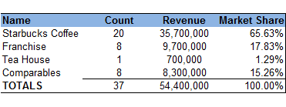

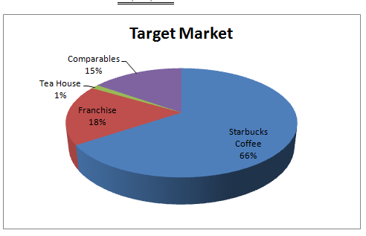

The Russet Cup is targeting three primary groups residing in their direct marketing area. These individuals prefer unique venues and avoid the big chains and franchises. They prefer their local neighborhood and will support local businesses if the business warrants.

Main Competitors

Roasterie Café
4511 W 119th St
Leawood, KS 66209
http://www.theroasterie.com/Cafe/

This competitor has been operating in the greater MSA since 2005 opening its first café in Brookside, Kansas and then at the Leawood location in 2010. The 3,300 square foot café offers an assortment of pastries, bagels and cookies. Beverages include Harney and Sons teas, signature blends, espresso and specialty drinks. The café has 11 employees and generated $11 million in revenues in 2011. The subject’s advantage is its smaller, cozier environment.

Take Five Coffee Bar
5336 W 151st St
Overland Park, KS 66224-8701
http://www.takefivecoffeebar.com/Welcome_to_Take_Five_Coffee_Bar

This competitor operates from a 3,300 square foot space. The café has WI-FI. In addition to serving coffees and smoothies, the café offers more food offerings with a full service kitchen offering light breakfasts, and sandwiches and wraps. In the evenings the café has musicians performing on a small stage. The Café also has a full liquor license. The broad offerings of amenities do not make this a true comp for the subject.

Homer’s Coffee House
7126 W 80th St
Overland Park, KS 66204-3715
http://www.homerscoffeehouse.com/about.php

This competitor operates from a 6,300 square foot space in a shopping center. The shop was established in 2001 and in 2011 reported $2 million in revenues. The shop employs 21 employees and provides music on the weekends. The subject’s advantage is its smaller, cozier, and quieter environment.

Morning Glory Espresso
5606 Johnson Dr
Mission, KS 66202-3323
http://www.morninggloryespresso.com/

This competitor is similar in size to the subject operating from 900 square feet in a retail shopping center. The Morning Glory Espresso has been operational since 2005 and has 3 employees and reported revenues of $300,000 in 2011. The coffee shop is open 6 days a week and open for breakfast. The shop has a full kitchen and in addition to pastries provides traditional breakfast offerings. The store is for sale, which could potentially impact market share.

Revo Cup Coffee
11030 Quivira Rd
Overland Park, KS 66210-1239
http://revocup.com/blog/

This competitor occupies a 2,100 square foot shop and has 7 employees. In 2011 its annual sales were reported to be $700,000. The Revo Cup is a specialized roaster. The owners from Ethiopia roast the Ethiopian coffee in the store themselves, providing a truly unique roasted coffee experience. Due to its unique roasting methods, and its limited food offerings, the subject should do well against this competitor.

Daily Dose Coffee and Bar
12056 W 135th St,
Overland Park, KS

This competitor occupies 2,700 square feet in a strip center and has been in operation since 2003. The coffee shop/bar is open 7 days a week and has a full kitchen. The shop occasionally offers live music on the weekends. The shop employs 9 and reported revenues in excess of $900,000 in 2011.

Java Crossing
8830 W 95th St
Overland Park, KS 66212-4051

This competitor leases a 2,700 square foot stand alone pad in a shopping center. The shop has drive throughs on both sides with a small walk up. The business was established in 2003 and is privately held. The store employs 9 and reported annual revenues of $900,000 in 2011. Known primarily for its convenience and breakfast sandwiches, this shop does not directly compete with the subject’s indoor sit down experience.

Hattie’s Fine Coffees
4195 Somerset Dr
Prairie Village, KS 66208-5242
http://www.hattiesfinecoffee.com/Home_Page.html

Established in 2005, Hattie’s has a staff of 17 and annual revenues of $1,700,000. The store is larger than the subject and occupies 5,100 square feet. Hattie’s Menu options are similar to the subject with a focus primarily on coffee, lattes, pastries and simple breakfast sandwiches. The facility has a great reputation and following. To capture a portion of this market, the subject will have to convince these customers that a cozier and quieter atmosphere is a more enjoyable café experience.

Market Segments
The Russet Cup is targeting the three top segments of the population representing 39% of the population in the Overland Park area:

- Boomburbs (29%) – Younger families with a busy, upscale lifestyle. Median age of 34. Most households operate on two incomes; median household income is $100,000. Product purchases reflect a suburban lifestyle; one of the top markets for SUVs, lawn /garden purchases and casual apparel. Technically savvy; active in golf, tennis and swimming.
- Enterprising Professionals (10%) – Young, highly educated, working professionals. Single or recently married, median age of 32, median household income is $65,000. Lifestyle reflects youth, mobility, and growing consumer clout. Residents go where the jobs are located. Love to travel and exercise; rely heavily on cell phones, PCs and the internet to stay connected.
- Prosperous Empty Nesters (12%) – Well educated and experienced, residents are enjoying the transition from child rearing to retirement. Median age is 46; median household income is $64,000. This market segment is active physically and financially. Display interest in homes/communities.

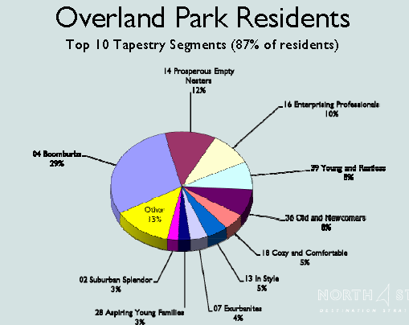

(Source: North Star)

Market Tests
Research from Yelp, FourSquare, and GooglePlaces, indicates the Overland Park market is in need of a new local café. The locals have been clamoring for the current private shops to improve service and/or reduce prices to keep pace with larger chains and franchises, thus providing a unique niche for the right entrant.

While employed by a national restaurant chain, Mr. Jones was constantly directing patrons to offsite coffeehouses for those seeking that final dessert and cup of coffee prior to finishing their evening. This is the reason he ultimately began seeking the location for his coffee house.

Target Market Segment Strategy
Most adult coffee drinkers said their lifelong habit began during their teenage years. In fact, 54% said they began drinking coffee between 13 and 19. Another 22% reported their coffee cravings started between the ages of 20 and 24. This means that 76% of adult coffee drinkers began drinking coffee by the time they were 24. So, despite the large amount of marketing and advertising directed at the younger age groups, savvy coffee shop owners will not forget to cater some of their offerings to the adult and senior market. (National Coffee Drinking Study).

The Russet Cup will offer a unique experience for coffee aficionado by offering a quiet and cozy yet sophisticated cafe and offer a sense of refinement and peace in an otherwise hectic and fast paced world. While other coffee shops cater to convenience with drive throughs or loud music venues late into the night, the Russet Cup will stand apart from its competitors with its quiet yet soothing ambience, capturing a truly unique (and much needed) market niche.

Market Needs
Coffee shop customers, by nature, are looking for something special — that’s why they are willing to pay so much for a cup of coffee! Many customers of the big national chains, while satisfied with their daily coffee would be intrigued to find a local coffee that is different. (SBA National Information Clearinghouse)

Market Trends
- Unique products (specialized roasts, local ingredients, locally themed or named drinks, custom drinks by the‘star’ barista, etc.)
- Games, puzzles, mind benders and other activities that encourage customers to linger over their coffee
- Hosting or sponsoring local events (entertainment, readings, book clubs, etc.)
- Using technology to creatively compete in marketing with the big chains — services like FourSquare, Yelp, and Google Places can increase visibility in the local market.
- Delivering amazing service from knowledgeable baristas — spend lots of time training staff and utilize online services like the American Coffee & Barista School
- Selling coffee-related items (and track down any co-marketing opportunities with a local community college or other student-related group in the area)

Market Growth
Despite the economic woes, 37% of total coffee consumed in the United States in 2011 was classified as “Gourmet.” According to the National Coffee Drinking Study This suggests consumers were set on drinking good coffee and visiting their local coffee shop even in the face of an uncertain economy. (First Research)

The sales of coffee dominate sales of hot beverages, making up 83.3% of the total hot beverage market in the U.S. Coffee consumption is expected to increase through 2015 at an average annual rate of 2.7%, while tea consumption is expected to increase through 2015 at an average annual rate of 3.1%. Positive expectations for continued growth in coffee sales, despite its “mature” product position in the market, are due to the innovations in premium coffee products (pods, single-serving instants, etc.) (First Research)

Positioning
The Russet Mug will position itself as a local coffeehouse or a ‘suburban’ coffeehouse providing a sanctuary for those in the ‘burbs’ without the hassle of having to drive downtown
- By charging similar prices as the large chains – the service and quality of the product will commensurate with the price
- The Russet Cup is genuinely unique place to gather and meet friends, and enjoy coffee
- Amenities such as free WIFI, chess games, comfy overstuffed chairs, create a relaxing environment
- The market does not need a café offering fast food breakfasts or another after hours bar
- The Russet Cup will position itself as the alternative to the chain/franchise/fast food coffee house.

Marketing Strategy and Implementation
The Russet Cup will provide a quiet and relaxing environment to enjoy gourmet roasted coffee and smoothies and an opportunity to visit with friends, catch up on one’s email, or read a chapter of a book. The Café will fill the great void providing originality in a sea of facsimile, corporate coffee shops. The café’s baristas will be extremely knowledgeable and offer assistance in any coffee purchase while simultaneously providing customers with outstanding service.

SWOT Analysis
The SWOT analysis examines the café’s strengths and weaknesses that need to be addressed. Further, this section examines the opportunities presented to Café as well as potential threats.

Strengths
- Based on its smaller size, the fact that it is not a franchise, the Russet Cup is a unique coffee shop concept unlike any other in the Overland Park market.
- The owner has firsthand experience, in operating and starting new restaurants,
- Handpicked baristas will bring professionalism and enthusiasm to the shop.

Weaknesses
- Franchises are the easiest way and often the safest conduit to start a café; the café will not have the backing of one of these established entities.
- The Russet Cup has a minimal budget and is competing against larger and more established coffeehouses for market share.

Opportunities
- The Overland Park demographics support the need for a unique coffee shop.
- Additional opportunities to target the active and recently retired target market and 45 years+ age group.
- A small slice of a much bigger pie is the goal. Only 40 percent of the nation’s coffee drinkers are consuming premium ground and whole bean coffee. Encouraging coffee drinkers to become coffee connoisseurs is the key to continued growth.
- The local coffeehouse/café market is $54 million

Threats
- The Morning Glory Coffee shop is currently for sale; should another independent purchase this café, it could pose significant threat to market share.

Strategy Pyramid
- In the short-term, a number of promotions and activities are planned around launch of the business to create awareness. The coffee shop will have a contest offering 20 bottomless mugs and will publicize this promotion via radio advertising, as well as countertop displays and posters in the shopping plaza.
- In addition, during its first year of operations the coffee shop will pass out a limited number of coupons for a free cup of coffee to prospective customers visiting the shopping center.

Unique Selling Proposition (USP)
The Russet Cup truly stands out from a crowded sea of coffee chains and franchises. What sets them apart from the competition is primarily its smaller cozier size combined with premium coffees served by knowledgeable baristas providing so much energy and enthusiasm for the products they sell.

Competitive Edge
The Russet Cup’s competitive edge, its size, is also its greatest attribute. Because they are small there is no red tape, and they can easily adjust business hours to say accommodate an afterhours book reading session whereas the corporate chains do not provide such an accommodation. The Russet Cup will truly cater to its patrons needs.

Marketing Strategy and Positioning
The Russet Cup utilizes a focus strategy on its market. By specifically targeting three primary segments they can cater specifically to their needs.

Senior Market (age 45+)
The Russet Cup will target this market simply by its well selected location. Although this demographic group could readily drive downtown, they prefer a local café to unwind and relax and historically become some of the most loyal patrons.

Newly Hired Employees
The café will attract regular customers (weekly or more) - particularly the newly employed (first job) by providing free WIFI services and providing interesting games in the customer area.

Young Families
The third targeted markets, younger families, often find that coffeehouse are not ‘kid’ friendly. The company has long term plans to create a combination coffee shop / play area so that parents and caregivers will have a place to meet with other adults while the children can enjoy the bounce houses, slides and indoor playground equipment.

Positioning Statement
The Russet Cup is a gourmet coffee lover’s gem. It is truly one of a kind coffee house offering outstanding gourmet coffees and blends, served by enthusiastic and knowledgeable baristas, in a warm, relaxed environment. It is the place to go to visit with friends or cozy up in a quiet corner with a good book either from the library or from one of the patron’s personal E-Books.

Pricing Strategy
The Russet Cup primarily utilizes competition based pricing. The café does not utilize coupons and discounts (other than opening promotion) because they believe that the most valuable customer demographic of daily coffee consumers is not influenced by discount programs or coupons.

Promotion and Advertising Strategy
- Online Advertising - The Russet Cup will advertise regularly on popular social media sites, such as Facebook. Compared to traditional print advertising, this is a cost effective tactic that will allow them to reach prospects in a highly targeted way (e.g., based on criteria such as age, gender, geography, etc.).
- Web Site - the Russet Cup will develop a simple Web site, which will provide basic information about the business, the menu, and links to their presence on the aforementioned social media channels.
- Radio Advertising - During the first six months of operation, and during the busy holiday shopping season, the business will advertise on local radio stations.
:

Website
The Russet Cup will have a simple website identifying its menu items of gourmet coffees, smoothies and pastries, along with the address, map and hours of operation. The website will also have a calendar of any upcoming events or sponsorships . The site will also have links to their social media sites – such as Facebook, Twitter, and Pinterest.

Marketing Programs
The café will also rely on signage and draw to its location. Price Chopper brings 10,000 shoppers weekly to its location.

Sales Strategy
The Russet Cup will use the following methods to increase sales revenue (as recommended by Andrew Hetzel on Better Coffee, Better Business):
- The menu will focus on the most profitable products sold. The café will always draw customer attention to the most profitable products.
- As warranted, the café will raise prices to bolster brand image. Prices communicate a perceived value of a product; so if set too low, the customers might assume that the beverages are inferior compared to the competition.
- Monitor flavoring inventory – Excess flavoring inventory ties up capital and valuable back room space for storage. The café will utilize 4-6 varieties, including sugar free offerings.
- Control waste and theft – audit sales and inventory reports to evaluate ingredient waste due to inefficient preparation, returned drinks and employee consumption. Retail locations can easily waste 20% or more of their daily sales these three key categories, which is a substantial and unnecessary loss.
- Monitor and evaluate hours of operation
- Run employee sales contests – The baristas are the salespeople and have a great deal of influence over the customer ordering process. All baristas will have some form of sales and customer service training to make each transaction active, rather than passive. Sales contests will emphasize high margin items or cross selling

Sales Forecast
The sales forecast assumes a conservative 5% increase in revenues during Year Two and 10% increase in Year Three. The following chart shows estimated sales over the next three years.

Table 5.6.1 Annual Sales Forecast

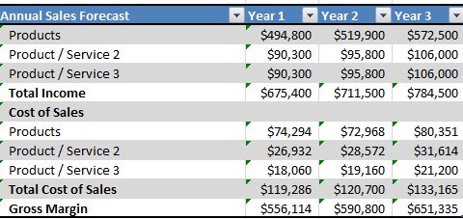

Sales Programs
The Russet Cup will run employee sales contests – The baristas are the salespeople and have a great deal of influence over the customer ordering process. All baristas will be required to have sales and customer service training to make each transaction. The sales contests will emphasize high margin items and cross selling.

Legal
The Russet Cup is organized as an S-Corporation formed in the state of Kansas.

Milestones
Listed below are the milestones for the Russet Cup:

Table 5.8 Milestones
Milestone | Date
Secure occupancy Overland Park location | Completed
Tenant improvements and build outs | Mar 20XX
Purchase furniture and décor | Apr 20XX
Assemble and hire barista team | May 20XX
Advertise on local radio station / mail fliers | May 20XX
Open for Business | Jun 20XX

Exit Strategy
In the event the store would have to close for business all assets would be sold at auction.

Organization and Management

Organizational Structure
The Russet Cup is formed as an S-Corporation wholly owned by Owen Jones.

Management Team
The Russet Cup will be owned 100% by Owen Jones. Mr. Jones a graduate of Kansas State University, has an undergraduate degree in business administration. During high school he worked as a waiter in a local hospital coffee shop that purchased its beans from a local roaster. In addition to being an avid coffee drinker himself, this job allowed him to learn about the business first-hand. In college, Jones worked in a campus coffeehouse for four years, eventually rising to the position of assistant manager. Following graduation, Jones secured a business development position for regional restaurant chain, which provided additional first-hand exposure to the food and beverage industry—especially the steps involved in establishing new locations.

Management Team Gaps
The Russet Cup will rely on its POS (Point of Sale) system to generate daily accounting and cost activity reports. Mr. Jones will supply these to an outside bookkeeper for preparation of annual income taxes.

Personnel Plan
Initially the café will hire 1 manager, 5 baristas, and 2 part time servers. In Year 2, the café plans to hire 1 additional full time barista.

Table 6.4 Personnel Plan
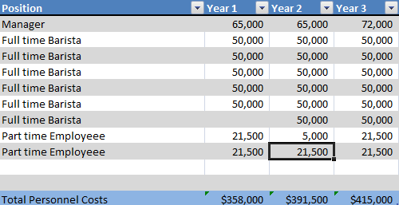

Board of Directors
NA

Financial Plan
The financial plan will cover the following:

- Required Cost of Start-Up
- Profit and Loss
- Cash Flow
- Balance Sheet
- Financial Ratios

Important Assumptions
- The sales forecast is conservative and assumes a 5% increase in Year 2, and a 10% in Year 3.
- The analysis accounts for economic seasonality – wherein some months revenues peak (such as holidays ) and wane in slower months.
- The analysis assumes the owner will take a much smaller salary compared to his baristas; at any time it is assumed that owner’s withdrawal is available at his discretion.
- Sales are cash basis – nonaccrual accounting
- Moderate ramp- up in staff over the 3 years forecast
- The average barista salary in 2012 is $50,000.
- In general, most cafes have an 85% gross profit margin
- In general most cafes have a 3% net profit margin

Start-Up Costs
Following are the needed start-up costs associated with the Russet Cup:

Table 7.2 Start-Up Costs
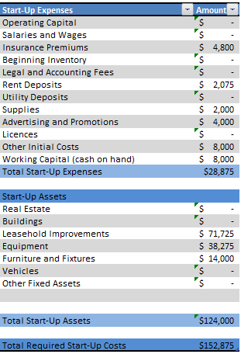

Source and Use of Funds
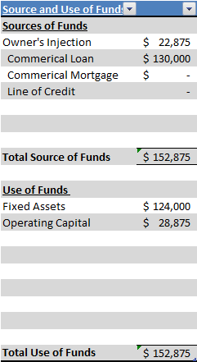

Break-Even Analysis

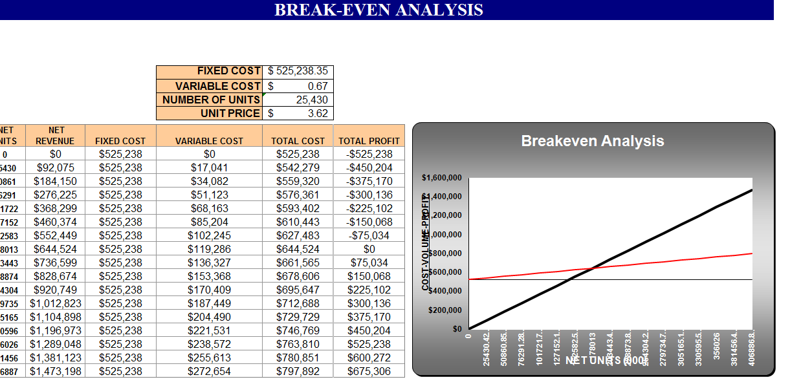

Projections

Projected Profit and Loss
The estimated profit and loss for the Russet Cup are as follows:
Table 7.5.1 Pro Forma Profit and Loss
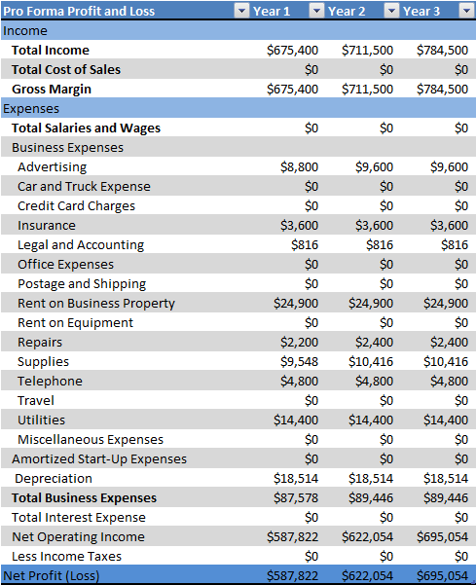

Projected Cash Flow
The statement of cash flow shows the incoming and outgoing cash of the business.

Table 7.5.2 Pro Forma Cash Flow

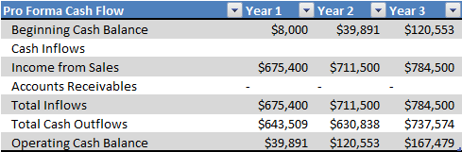

Projected Balance Sheet

Table 7.5.3 Pro Forma Balance Sheet
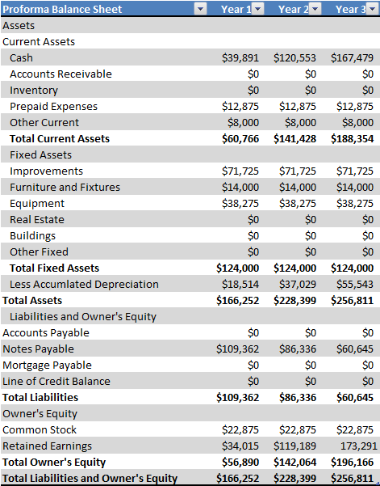

Business Ratios
The analysis is based on NAICS (North American Industry Classification System) 722213 – Restaurant / Lodging – Snack and Non-Alcoholic Beverage Bars.

Table 7.6 Ratio Analysis
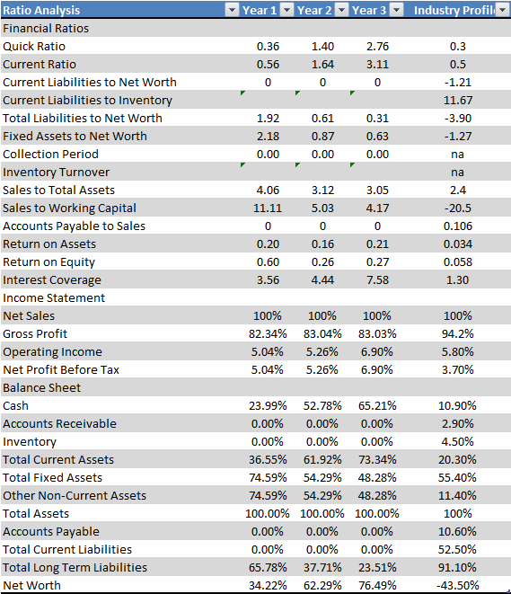

This business plan template can be downloaded at:
http://www.fastbusinessplans.com/business-plan-template.html

Free sample business plans are available at:
http://www.fastbusinessplans.com/sample-business-plans.html.

Many articles to assist in guiding you through the writing of your business plan are available at:
http://www.fastbusinessplans.com/business-plan-guide.html

